American Heart Month (October 4-10)
Drafted January 22, 2016

For Immediate Release: (INSERT DATE)
Contact: (INSERT NAME, PHONE NUMBER)

Local Advocates, New Ad Encourage Quitting Tobacco for Better Heart Health

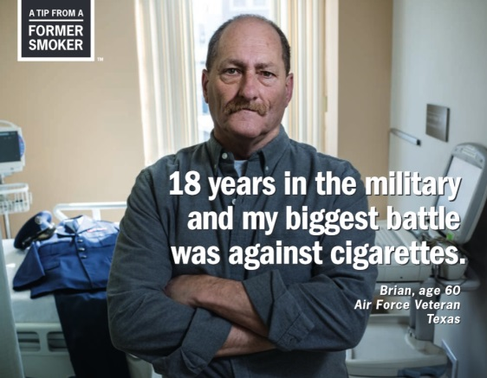
(CITY, WI) – February is American Heart Month, an annual event to raise awareness of cardiovascular disease (CVD) and promote better heart health.

Cardiovascular disease claims 800,000 U.S. lives annually, and covers a host of disorders of the heart and blood vessels that occur when plaque builds up in the walls of the arteries. This buildup narrows the arteries, making it harder for blood to flow through. From there, blood clots can form and lead to heart attack or stroke.

A new ad in Centers for Disease Control and Prevention’s (CDC) successful Tips from Former Smokers Campaign is helping to raise awareness of the link the between smoking and CVD. The ad features Brian, an Air Force veteran who suffered from heart failure due to smoking and needed a heart transplant as a result. The powerful ad, part of a series of four, will air between now and June.

“QUOTE DESCRIBING YOUR REACTION TO THE AD,” said (NAME) of the (COALTION NAME). “QUOTE ALONG THE LINES OF BRIAN SHOULD BE THANKED NOT ONLY FOR HIS SERVICE TO OUR COUNTRY, BUT ALSO HIS BRAVERY IN TELLING HIS STORY.”

Smoking causes one of every three CVD deaths, so individuals can reduce their CVD risk by quitting tobacco use or never starting in the first place. BACK UP THIS STATEMENT BY GRABBING SOME OF THE HEART/CVD STATS FOUND AT http://www.cancer.org/healthy/stayawayfromtobacco/guidetoquittingsmoking/guide-to-quitting-smoking-benefits.

The coalition also shared other things individuals can do to improve their heart health, including getting 30 minutes of exercise on most days, eating more fruits and vegetables, reducing sodium intake, and getting their blood pressure and Cholesterol checked by their physician.

Brian’s ad can be viewed at http://youtube.com/watch?v=WFPbXxU8Gwc. For more on local tobacco prevention efforts, visit (COALITION URL, SOCIAL MEDIA, ETC.). Tobacco users can receive free help by calling the Wisconsin Tobacco Quit Line at 1-800-QUIT NOW.
###

