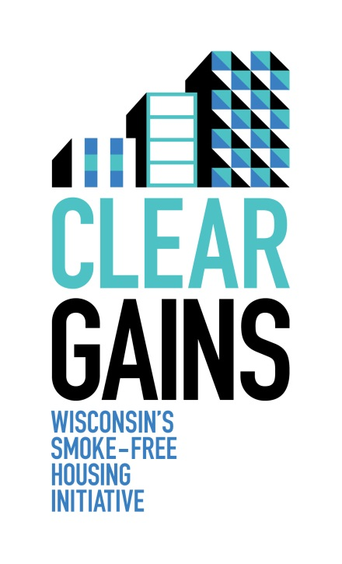
Clear Gains Network Partnership Contact Information

Clear Gains administered by the American Lung Association, is Wisconsin’s Smoke-Free Housing Initiative.

Vision: Smoke-free housing for all Wisconsinites.

Mission: To inform Wisconsin property owners about the business and health benefits of smoke-free policies in multi-family dwellings, and to provide resources for making residential properties smoke-free.

Network: Is a collaborative group of statewide organizations that provide support and guidance to the smoke-free housing initiative.

Organization Information:
Organization Name: ____________________________________________________________________
Address:______________________________________________________________________________
Representative Information:
Name:________________________________________________________________________________
Title:_________________________________________________________________________________
Phone Number: ________________________________________________________________________
Email:________________________________________________________________________________
General Information:
Preferred contact method:_______________________________________________________________
How do you intend to support the Clear Gains Initiative? _____________________________________________________________________________________
_____________________________________________________________________________________
How can the Clear Gains Initiative help your organization? __________________________________________________________________________________________________________________________________________________________________________

