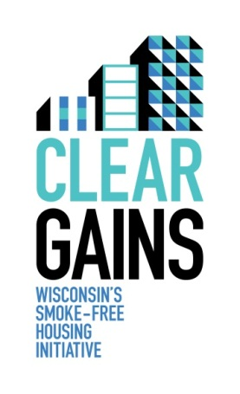
MUH Policy Tracker

It is an important part of Clear Gains that partners around the state track all existing and new smoke-free policies in a coordinated fashion. This tracking form will ensure that everyone is collecting the same information for the statewide list of smoke-free properties. Please refer to the example below and read the instructions before completing and submitting this form.

Save the document as follows: [County].[ApartmentName].Tracking.[year]
Example: Chippewa.KnitterGardens.Tracking.2012

Save the policy as follows: [County].[ApartmentName].Policy.[year]

E-mail completed worksheet AND lease addendum/policy to: Karen Doster at Karen.Doster@dhs.wisconsin.gov. If you have any questions, please call at 608-267-6768.

Coordinator/Submitter Information
Name: Disa Patel
E-mail patel@org.com
Property Management Information
Property Management Company Name: Staats Management Company
Property Management Company Contact Name: Melissa Horn
Property Management Company Contact Phone Number: 414-123-4567
Property Management E-mail: staats@ma.co
Smoke-Free Property Information
Smoke-Free Property Name: Knitter Gardens
Smoke-Free Property Address: 89 N. Rainbow Drive
Smoke-Free Property City: Cheeseburg, WI
Smoke-Free Property County: Chippewa
Number of Units Covered by Smoke-Free Policy: 14
Smoke-Free Policy Information
Policy “Star Level” (check all that applies): ☐ Building only, including individual units
☒ Smoke-free patios and balconies
☐ Smoke-free entrances
☐ Outdoor designated smoking area
☐ 100% entire property, inside and out
Policy includes the use of electronic nicotine devices such as e-cigarettes:
☒ Yes
☐ No
Smoke-Free Effect Date (start of implementation): Oct. 1, 2012
Date 100% Smoke-Free (end of implementation): Jan. 1, 2013
Subsidized Housing? (drop-down list) Privately Owned, Section 8, Public Housing
Number of units: 18

Clear Gains Policy Tracker
(please enter information below)

Coordinator/Submitter Information
Name: Click here to enter text.
E-mail Click here to enter text.

Property Management Information
Property Management Company Name: Click here to enter text.
Property Management Company Contact Name: Click here to enter text.
Property Management Company Contact Phone Number: Click here to enter text.
Property Management E-mail: Click here to enter text.

Smoke-Free Property Information
Smoke-Free Property Name: Click here to enter text.
Smoke-Free Property Address: Click here to enter text.
Smoke-Free Property City: Click here to enter text.
Smoke-Free Property County: Click here to enter text.
Number of Units Covered by Smoke-Free Policy: Click here to enter text.

Smoke-Free Policy Information
Policy “Star Level” (check all that applies):
☐ Building only, including individual units
☐ Smoke-free patios and balconies
☐ Smoke-free entrances
☐ Outdoor designated smoking area
☐ 100% entire property, inside and out
Policy includes the use of electronic nicotine devices such as e-cigarettes:
☐ Yes
☐ No
Smoke-Free Effect Date (start of implementation): Click here to enter text.
Date 100% Smoke-Free (end of implementation): Click here to enter text.
Subsidized Housing? (drop-down list) Choose an item.
Number of units: Click here to enter text.

