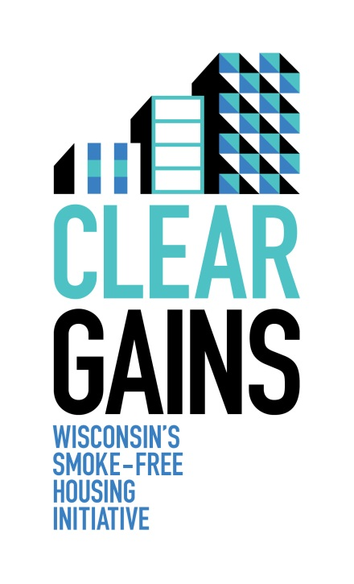

Clear Gains is Wisconsin’s Smoke-Free Housing Initiative.

Vision: Smoke-free housing for all Wisconsinites.

Mission: To inform Wisconsin property owners about the business and health benefits of smoke-free policies in multi-family dwellings and to provide resources for making residential properties smoke-free.

The Clear Gains Network is a collection of statewide organizations that provides support and guidance to the smoke-free housing initiative. We feel you would be an invaluable partner in this effort and provide a unique and important perspective to the Network. We hope you will consider exploring a further partnership around smoke-free housing.

We formally ask for your support of the Clear Gains Initiative by becoming a
partner of the Clear Gains Network.

A Clear Gains Network partner:
- Assigns a representative from the organization to help inform the Clear Gains Initiative
- Attends an annual Clear Gains Network meeting
- Receives acknowledgement as a Clear Gains Network partner in promotional materials and presentations
- Pursues additional collaboration opportunities when appropriate
Clear Gains Network partners include:

